**Final Project Document**

Project Deliverable 4 - IS 420

Professor Bandaru

Group 8

Members

Donald Duncan

Mykah Rather

Abou Keita

Jamal Cody

Gianni Laditi

**Drop Table Statements**

drop table schedule_station;

drop table schedule;

drop table trip;

drop table transactions;

drop table line_station;

drop table station;

drop table train_line;

drop table metro_card;

drop table discount;

drop table rider;

**Create Table Statements**

CREATE TABLE rider(

rider_id NUMBER NOT NULL,

rider_first_name VARCHAR2(50 CHAR) NOT NULL,

rider_last_name VARCHAR2(50 CHAR) NOT NULL,

rider_email VARCHAR2(50 CHAR) NOT NULL UNIQUE,

rider_password VARCHAR2(50 CHAR) NOT NULL,

rider_age NUMBER NOT NULL,

CONSTRAINT rider_pk PRIMARY KEY(rider_id)

);

CREATE TABLE discount(

discount_id NUMBER NOT NULL,

rate NUMBER NOT NULL,

CONSTRAINT discount_pk PRIMARY KEY (discount_id)

);

CREATE TABLE metro_card (

card_id NUMBER NOT NULL,

card_balance NUMBER NOT NULL,

rider_id NUMBER NOT NULL,

discount_id NUMBER NOT NULL,

CONSTRAINT metro_card_pk PRIMARY KEY(card_id),

CONSTRAINT rider_fk FOREIGN KEY (rider_id) REFERENCES rider (rider_id),

CONSTRAINT discount_fk FOREIGN KEY (discount_id) REFERENCES discount (discount_id)

);

CREATE TABLE train_line(

line_id NUMBER NOT NULL,

line_name VARCHAR2(50 CHAR) NOT NULL UNIQUE,

station_total NUMBER NOT NULL,

CONSTRAINT line_pk PRIMARY KEY (line_id)

);

CREATE TABLE station(

station_id NUMBER NOT NULL,

station_name VARCHAR2(50 CHAR) NOT NULL UNIQUE,

station_address VARCHAR2(50 CHAR) NOT NULL UNIQUE,

status NUMBER(1) DEFAULT (0),

CONSTRAINT station_pk PRIMARY KEY (station_id)

);

CREATE TABLE trip (

trip_id NUMBER NOT NULL,

entrance_station_id NUMBER NOT NULL,

exit_station_id NUMBER NOT NULL,

entrance_time INTERVAL DAY TO SECOND NOT NULL,

exit_time INTERVAL DAY TO SECOND NOT NULL,

card_id NUMBER NOT NULL,

cost DECIMAL NOT NULL,

CONSTRAINT trip_pk PRIMARY KEY(trip_id),

CONSTRAINT entrance_station_fk FOREIGN KEY (entrance_station_id) REFERENCES station (station_id),

CONSTRAINT exit_station_fk FOREIGN KEY (exit_station_id) REFERENCES station (station_id),

CONSTRAINT metro_card_fk FOREIGN KEY (card_id) REFERENCES metro_card (card_id)

);

CREATE TABLE line_station(

line_id NUMBER NOT NULL,

station_id NUMBER NOT NULL,

sequence_num NUMBER NOT NULL,

CONSTRAINT line_fk FOREIGN KEY (line_id) REFERENCES train_line (line_id),

CONSTRAINT station_fk FOREIGN KEY (station_id) REFERENCES station (station_id)

);

CREATE TABLE transactions(

transaction_id NUMBER NOT NULL,

card_id NUMBER NOT NULL,

addition_date DATE NOT NULL,

addition_time INTERVAL DAY TO SECOND NOT NULL,

addition_amount NUMBER NOT NULL,

CONSTRAINT transaction_pk PRIMARY KEY (transaction_id),

CONSTRAINT metro_card_to_transaction_fk FOREIGN KEY (card_id) REFERENCES metro_card (card_id)

);

CREATE TABLE schedule(

schedule_id NUMBER NOT NULL,

line_id NUMBER NOT NULL,

direction NUMBER NOT NULL,

CONSTRAINT schedule_pk PRIMARY KEY (schedule_id),

CONSTRAINT line_to_schedule_fk FOREIGN KEY (line_id) REFERENCES train_line (line_id)

);

CREATE TABLE schedule_station(

arrival_time INTERVAL DAY TO SECOND NOT NULL,

schedule_station_id NUMBER NOT NULL,

schedule_id NUMBER NOT NULL,

CONSTRAINT station_schedule_fk FOREIGN KEY (schedule_station_id) REFERENCES station (station_id),

CONSTRAINT schedule_fk FOREIGN KEY (schedule_id) REFERENCES schedule (schedule_id)

);

**ERD**

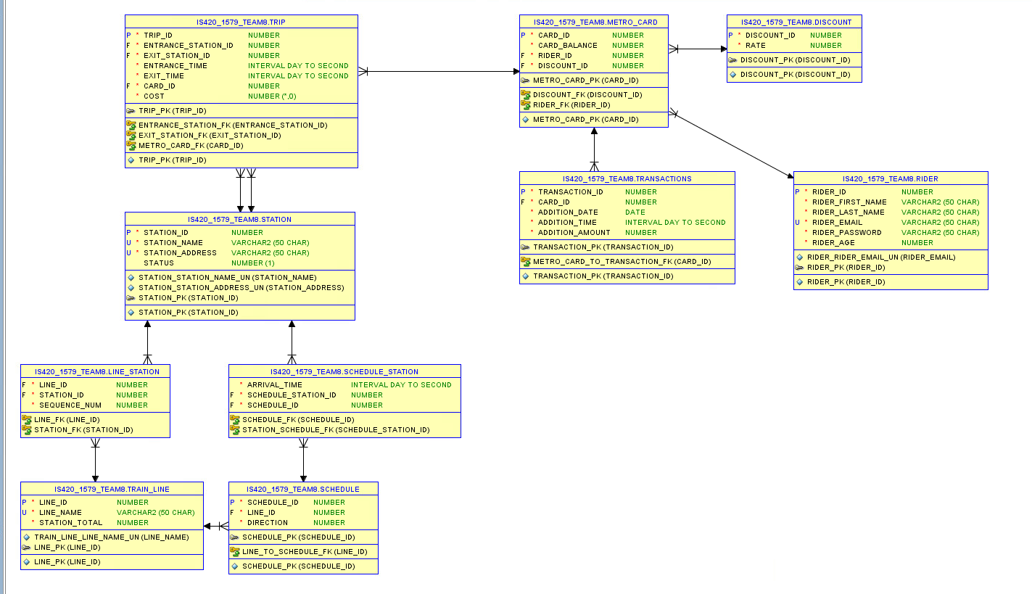

**Task Specifications**

Task 1 (Donald Duncan) –

1. Passenger needs to create a rider account
   1. Input
      1. Must Include
         1. Email address
         2. Name
         3. Password
         4. Age
      2. Check for Valid email
         1. Input email
   2. Output
      1. Check for Valid email
         1. If valid print “Account Exists”
         2. If not create a new account
            1. New account id

Age

Print new account ID

* 1. Test
     1. Using a valid email
     2. Then using invalid email
        1. Forcing the program to create a new account

Task 2 (Donald Duncan) –

1. Login to an Account
   1. Input
      1. Email address
      2. Password
   2. Output
      1. If login information is correct
         1. print successful login
      2. If not email does not match
         1. print no such account
      3. If email is correct and password is not
         1. print wrong password
   3. Test
2. Use official account to receive successful login message
3. Use wrong email to print no such account
4. Use incorrect password to print wrong password

Task 3 (Abou Keita) –

1. INPUT
   1. account ID and initial payment
      1. Account_id is verified against database to see if it exist
      2. If yes, then a new row to the metro card table is added with the given account id, balance and a new card id (using sequence).
      3. If no, print out a message saying “the account does not exist”
2. OUTPUT
   1. Verify the age of passenger [case statement]
      1. If the holder's age <= 12, set discount id to 2 (child).
      2. If the holder's age >= 65, set discount id to 3 (senior).
      3. Otherwise the discount rate should be 1 (regular).

Task 4 (Abou Keita) –

1. INPUT
   1. Passenger should be allowed to add money to an existing card using input of account id and amount
   2. Metro card with card ID is checked for existence or else print out “saying no such card ”
2. OUTPUT
   1. If card ID EXISTS
      1. Add input amount to balance of the card
      2. Insert a row to metro card transaction table with time as current time
      3. Print: new balance
   2. If card ID DOES NOT EXIST
      1. Print: no such card.

Task 5 (Mykah Rather) –

1. Input
   1. Passenger will be able to list all cards related to an account
      1. Card information listed in table
2. Output
   1. Print out card id
   2. Print out card balance
   3. Print out error message ‘invalid account id’ if account is null/not valid

Task 6 (Mykah Rather) –

1. Input
   1. Passenger will be able to look up all transactions of a card
      1. Transaction information of a card listed in table
2. Output
   1. Print out transactions of a card in given time frame
   2. Print out card id
   3. Print out start date
   4. Print out end date
   5. Print out error message ‘invalid card’
      1. Otherwise, print out transaction date and amount added for each transaction during the period.

Task 7 (Jamal Cody) –

1. Input information to trip table
   1. Input:
      1. card Id
      2. Entrance station id
      3. Exit station id
      4. Entrance time
      5. Exit time
2. Output
   1. If card id is not valid, print error message ‘invalid card’
   2. Else print updated trip id, computed cost, entrance station name and exit station name
   3. Update card balance

Task 8 ( Gianni Laditi) –

1. Create PL/SQL procedure
2. Input:
3. Time of arrival
4. Name of station
5. Output
6. Stations and their departure time
7. Station id
8. Departure time
9. Line name
10. Direction 1or 2
11. Else “Station not found”

Task 9 (Mykah Rather) –

1. Create PL/SQL function
   1. Input:
      1. Name of an origin station
      2. Name of a destination station
      3. ID of line station(s) are on
   2. Output:
      1. Direction (1 for increasing order and 2 for descending order)

Task 10 (Jamal Cody)

1. Input:
   1. Start time
   2. Time gap
   3. Names of origin and destination station
   4. Line name
2. Output
   1. If station name is invalid print error message ‘wrong station’
   2. If line name is invalid print error message ‘wrong line name’
   3. If all names are valid, print origin station and destination station
   4. Print out schedule ID
   5. Print scheduled arrival time at origin
   6. Print Destination station for each schedule

Task 11 (Gianni and Abou)

1. INPUT
   1. Passenger origin
   2. Two destination stations assumed to be on two different lines
   3. At least one station that the passenger can transfer between these two lines.
      1. First needs to check:
         1. Whether the two station names exist and
         2. Whether they are on different lines.
2. OUTPUT
   1. Not valid
      1. Print out an error message explaining the problem.
   2. Valid
      1. Prints out the transfer station name
      2. Line name
      3. Direction (1 or 2) from origin to transfer station
      4. Direction from transfer station to destination

Task 12 (Donald Duncan)

1. Create a Procedure
   1. Input
      1. Procedure
   2. Output
      1. Print
         1. Total number of accounts
         2. Total spending (cost of all trips)
         3. Average number of trips per account
         4. The station appears most often as the entrance station in trips
         5. The station appears most often as the exit station in trips

**Procedure/Function Statements**

**Task 1: (Donald)** allow a passenger to create a rider account with input including email address, name, password, and age. First check whether email exists. If so, print a message that the account exists. Otherwise, create a new rider account with new account id and age and print out the new account id.

CREATE OR REPLACE PROCEDURE createRiderAccount(first_name VARCHAR2, last_name VARCHAR2, email VARCHAR2, password VARCHAR2, age NUMBER)

AS

new_rider_id NUMBER;

account_exists NUMBER := 0;

BEGIN

SELECT COUNT(*) INTO account_exists

FROM rider

WHERE rider_email = email;

IF (account_exists <> 0) THEN

DBMS_OUTPUT.PUT_LINE('An account already exists with the provided email: ' || email);

RETURN;

END IF;

INSERT INTO rider (rider_first_name, rider_last_name, rider_email, rider_password, rider_age)

VALUES (first_name, last_name, email, password, age)

returning rider_id INTO new_rider_id;

DBMS_OUTPUT.PUT_LINE('New account id: ' || new_rider_id);

END;

**Task 2:(Donald)** login to an account with email address and password. If both matches an existing account, print a message login is successful. If email does not match, print a message no such account. If email matches but password does not match, print wrong password.

CREATE OR REPLACE PROCEDURE loginRider(email VARCHAR2, password VARCHAR2)

AS

email_exists NUMBER := 0;

rider_account_id NUMBER := 0;

BEGIN

SELECT COUNT(*) INTO email_exists

FROM rider

WHERE rider_email = email;

IF (email_exists = 0) THEN

DBMS_OUTPUT.PUT_LINE('No account exists with the provided email: ' || email);

RETURN;

END IF;

SELECT rider_id INTO rider_account_id

FROM rider

WHERE rider_email = email

AND rider_password = password;

DBMS_OUTPUT.PUT_LINE('Login is successful!');

EXCEPTION

WHEN NO_DATA_FOUND THEN

DBMS_OUTPUT.put_line('Wrong password!');

END;

**Task 3:(Abou)**

Create a procedure to allow a passenger to buy a metro card and add it to an existing account. Input includes account id, initial balance (payment).

* The procedure first checks if the input account id exists. If not, print out a message saying that the account does not exist.
* Otherwise the procedure inserts a new row to the metro card table with the given account id, balance and a new card id (using sequence).
* In addition, please look up the age of the account holder. If holder's age <= 12, set discount id to 2 (child). If holder's age >= 65, set discount id to 3 (senior). Otherwise the discount rate should be 1 (regular).

create or replace procedure BuyNewCard (acct_id integer,InitialPayement integer)

As

checkID integer:= 0;

newPayement integer:= 0;

begin

SELECT acct_id INTO checkid

FROM metro_card

WHERE rider_id = acct_id;

IF (checkID = 0) THEN

DBMS_OUTPUT.PUT_LINE('No account exists with the account ID: ' || acct_id);

RETURN;

END IF;

Update metro_card set card_balance = card_balance + InitialPayement

WHERE rider_id = acct_id;

SELECT card_balance into newPayement

From metro_card

WHERE rider_id = acct_id;

DBMS_OUTPUT.PUT_LINE('Account ID is: ' || checkID);

DBMS_OUTPUT.PUT_LINE('New Balance is: ' || newpayement);

end;

**Look-up Age for discountID**

*SET SERVEROUTPUT ON*

*DECLARE*

*Discount_ID INT;*

*Age INT;*

*BEGIN*

*SELECT AGE INTO Age*

*FROM RIDERS*

*WHERE account_id = 3;*

*IF AGE <= 12 THEN*

*Discount_ID := 2;*

*dbms_output.put_line( 'The discount ID for this rider is: ' || Discount_ID );*

*ELSIF AGE >= 65 THEN*

*Discount_ID := 3;*

*dbms_output.put_line( 'The discount ID for this rider is: ' || Discount_ID );*

*ELSE*

*Discount_ID := 1;*

*dbms_output.put_line( 'The discount ID for this rider is: ' || Discount_ID );*

*END IF;*

*END;*

**Task 4:(Abou)**

**Allow a passenger to add money to an existing card, with input card id and amount. The procedure first checks if there is a metro card with given card id. If not, print a message saying no such card. Otherwise, add input amount to balance of the card and insert a row to metro card transaction table with time as current time. Finally print out new balance.**

create or replace procedure AddMoney(inputcard_id in INT, amount in number, printAmount out number)

IS

begin

Update metro_card set card_balance = card_balance + amount

WHERE card_id = inputcard_id;

SELECT card_balance into printAmount

From metro_card

WHERE card_id = inputcard_id;

exception

when no_data_found then

dbms_output.put_line('no such card id exist');

end;

**Task 5:(Mykah)** *Create a procedure to allow a passenger to list all cards related to an account, and print out card id and balance on each card. In case the account id is not valid, print out a message saying invalid account id.*

-- Task 5

SET serveroutput ON;

CREATE OR REPLACE PROCEDURE CardDetails (rider_id in number) IS

/*

Since each account can be uniquely identified

by the associated rider ID, the user is prompted

for said rider number

*/

r_id rider.rider_id%TYPE := '&r_id';

/*

This task takes a given account id for a rider

and matches said id to all metro cards linked

to said account

*/

c_id metro_card.card_id%TYPE;

c_balance metro_card.card_balance%TYPE;

BEGIN

IF r_id = rider_id THEN

SELECT card_id, card_balance

INTO c_id, c_balance

FROM metro_card

WHERE rider_id = r_id;

dbms_output.put_line('Card ID: ' || c_id);

dbms_output.put_line('Card Balance: ' || c_balance);

END IF;

EXCEPTION

WHEN NO_DATA_FOUND THEN

dbms_output.put_line('Account Not Found');

END;

/

**Task 6:(Mykah)** *Create a procedure to allow a passenger to look up all transactions of a card in a given time period. Input includes card id, start date and end date. In case the input card id is invalid, print a message saying invalid card. Otherwise print out the transaction date and amount added for each transaction during the period.*

-- Task 6

SET serveroutput ON;

CREATE OR REPLACE PROCEDURE CardTransaction (card_id in number) IS

-- take input from user for card id, start date, and end date

card_id_input transactions.card_id%TYPE := &card_id_input;

start_date transactions.transaction_date%TYPE := '&start_date';

end_date transactions.transaction_date%TYPE := '&end_date';

-- declare variables for requested output values

t_time transactions.transaction_date%TYPE;

time_check transactions.addition_time%TYPE;

balance_check transactions.addition_amount%TYPE;

BEGIN

IF card_id_input = card_id THEN

SELECT transaction_date, addition_time, addition_amount

INTO t_time, time_check, balance_check

FROM transactions

WHERE card_id = card_id_input;

dbms_output.put_line('Transaction Date: ' || t_time);

dbms_output.put_line('Amount Deposited: ' || balance_check);

END IF;

EXCEPTION

WHEN NO_DATA_FOUND THEN

dbms_output.put_line('INVALID CARD');

END;

/

**Task 7:(Jamal)**

**Task 8:(Gianni)**

Create a procedure that given a time (just hours and minutes) and station name, list all schedules departing that station within X minutes after the given time. Here X is an input. The procedure first checks whether the input station name matches any existing station. If not it prints an error message saying wrong station name. Otherwise it prints out schedule ID, line name, direction (1 or 2), scheduled arrival time at the station.

SET serveroutput ON;

CREATE OR REPLACE PROCEDURE checkdeparture(station_name, arrival_time)

IS

-- take input from user for time, and station name

time_input schedule_station.arrival_time%TYPE := '&time_input';

station_input station.station_name%TYPE := '&station_input';

-- declare variables for requested output values

schedule_id_output schedule.schedule_id%TYPE;

line_name_output train_line.line_name%TYPE;

direction_output schedule.direction%TYPE;

station_name_check station.station_name%TYPE;

BEGIN

SELECT station.station_name

INTO station_name_check

FROM station

WHERE station_name = station_input;

FOR result_info IN (

SELECT schedule_id, direction

INTO line_name_output, direction_output

FROM schedule, train_line

WHERE schedule.line_id = train_line.line_id

)

LOOP

dbms_output.put_line('Line: ' || line_name_output ||

' Direction: ' || direction_output);

END LOOP;

EXCEPTION

WHEN NO_DATA_FOUND THEN

dbms_output.put_line('Station Not Found');

END;

**Group Tasks**

**Task 9:**

CREATE OR REPLACE FUNCTION task9(origin_station IN VARCHAR2, destination_station IN VARCHAR2, line_id IN NUMBER)

RETURN NUMBER

IS

origin_seq_num NUMBER;

destination_seq_num NUMBER;

BEGIN

-- get the sequence number of the origin station

SELECT sequence_num INTO origin_seq_num

FROM station

JOIN line_station ON station.station_id = line_station.station_id

WHERE line_id = line_id

AND station_name = origin_station;

-- get the sequence number of the destination station

SELECT sequence_num INTO destination_seq_num

FROM station

JOIN line_station ON station.station_id = line_station.station_id

WHERE line_id = line_id

AND station_name = destination_station;

-- check which station has a bigger sequence number to determine the direction

IF (origin_seq_num < destination_seq_num) THEN

RETURN 1;

ELSE

RETURN 2;

END IF;

END task9;

**Task 10:**

CREATE OR REPLACE PROCEDURE task10(start_time INTERVAL DAY TO SECOND, time_gap INTERVAL DAY TO SECOND, origin_station VARCHAR2, destination_station VARCHAR2, train_line_name VARCHAR2)

AS

TYPE array_of_varchar2 IS VARRAY(50) OF VARCHAR2(50);

TYPE array_of_interval IS VARRAY(50) OF INTERVAL DAY TO SECOND;

arrivals_at_origin array_of_interval;

arrivals_at_destination array_of_interval;

schedule_ids array_of_varchar2;

schedule_ids_destination array_of_varchar2;

j NUMBER;

line_direction NUMBER;

line_id NUMBER;

valid_origin NUMBER := 0;

valid_destination NUMBER := 0;

is_line_name_valid NUMBER := 0;

are_stations_on_same_line NUMBER := 0;

BEGIN

SELECT COUNT(*) INTO valid_origin

FROM station

WHERE station_name = origin_station;

--if there are 0 results, then the station name is invalid

IF (valid_origin = 0) THEN

DBMS_OUTPUT.put_line('Invalid origin station name: ' || origin_station);

RETURN;

END IF;

SELECT COUNT(*) INTO valid_destination

FROM station

WHERE station_name = destination_station;

--if there are 0 results, then the station name is invalid

IF (valid_destination = 0) THEN

DBMS_OUTPUT.put_line('Invalid destination station name: ' || destination_station);

RETURN;

END IF;

SELECT COUNT(*) INTO is_line_name_valid

FROM station

join line_station

ON station.station_id = line_station.station_id

join train_line

ON train_line.line_id = line_station.line_id

WHERE train_line.line_name = train_line_name;

--if there are 0 results, then the line name is invalid

IF (is_line_name_valid = 0) THEN

DBMS_OUTPUT.put_line('Invalid line name: ' || train_line_name);

RETURN;

END IF;

SELECT COUNT(*) INTO are_stations_on_same_line

FROM station

join line_station

ON station.station_id = line_station.station_id

join train_line

ON train_line.line_id = line_station.line_id

WHERE train_line.line_name = train_line_name

AND (station.station_name = origin_station

OR station.station_name = destination_station);

--if there aren't 2 results, then at least one of the stations isn't on the line given as parameter

IF (are_stations_on_same_line != 2) THEN

DBMS_OUTPUT.put_line('The stations aren''t both on train line: ' || train_line_name);

RETURN;

END IF;

--get line id

SELECT line_id INTO line_id

FROM train_line

WHERE train_line.line_name = train_line_name;

--find out the correct direction using task9

line_direction := task9(origin_station, destination_station, line_id);

--apply all filters to select the viable schedule ids and the arrivals at the origin

SELECT schedule.schedule_id, schedule_station.arrival_time BULK COLLECT INTO schedule_ids, arrivals_at_origin

FROM schedule

join schedule_station

ON schedule_station.schedule_id = schedule.schedule_id

join station

ON schedule_station.schedule_station_id = station.station_id

WHERE line_id = line_id

AND station_name = origin_station

AND arrival_time BETWEEN start_time AND (start_time + time_gap)

AND direction = line_direction

ORDER BY 2 ASC;

--get all arrival times in destination station from the start of the time window

SELECT schedule.schedule_id, schedule_station.arrival_time BULK COLLECT INTO schedule_ids_destination, arrivals_at_destination

FROM schedule

join schedule_station

ON schedule_station.schedule_id = schedule.schedule_id

join station

ON schedule_station.schedule_station_id = station.station_id

WHERE line_id = line_id

AND station_name = destination_station

AND arrival_time >= start_time

AND direction = line_direction

ORDER BY 1 ASC;

--loop over all viable trips and print the schedule

FOR i IN 1..schedule_ids.COUNT LOOP

-- synchronize the station arrival arrays

j := i;

IF (schedule_ids(i) != schedule_ids_destination(i)) THEN

j := i + 1;

END IF;

DBMS_OUTPUT.put_line('Schedule id: ' || schedule_ids(i) || ' arrivat at ' || origin_station || ': ' || arrivals_at_origin(i) || ' arrival at ' || destination_station || ': ' || arrivals_at_destination(j));

END LOOP;

END;

**Task 11:**

CREATE OR REPLACE PROCEDURE task11(origin_station VARCHAR2, destination_station VARCHAR2)

AS

TYPE array_of_varchar2 IS VARRAY(50) OF VARCHAR2(50);

TYPE array_of_number IS VARRAY(50) OF NUMBER;

direction1 NUMBER;

direction2 NUMBER;

transfer_station_names array_of_varchar2;

--transfer_station_seq_origin too long var name

ts_seq_origin array_of_number;

--transfer_station_seq_destination too long var name

ts_seq_destination array_of_number;

origin_station_seq NUMBER;

destination_station_seq NUMBER;

origin_line_name VARCHAR(50);

origin_line_id NUMBER;

destination_line_name VARCHAR(50);

destination_line_id NUMBER;

is_origin_valid NUMBER := 0;

is_destination_valid NUMBER := 0;

num_stations_on_same_line NUMBER := 0;

multi_station_line VARCHAR(50);

BEGIN

SELECT COUNT(*) INTO is_origin_valid

FROM station

WHERE station_name = origin_station;

--if there are 0 results, then the station name is invalid

IF (is_origin_valid = 0) THEN

DBMS_OUTPUT.put_line('Invalid origin station name: ' || origin_station);

RETURN;

END IF;

SELECT COUNT(*) INTO is_destination_valid

FROM station

WHERE station_name = destination_station;

--if there are 0 results, then the station name is invalid

IF (is_destination_valid = 0) THEN

DBMS_OUTPUT.put_line('Invalid destination station name: ' || destination_station);

RETURN;

END IF;

-- select the first row, with the largest group count for line_id

SELECT total_stations, line_name INTO num_stations_on_same_line, multi_station_line FROM (

-- select the line_ids for the two station

-- group the rows by line_name, and check the group count

-- if the stations are on separate lines, group counts will be 1

-- sort by descending

SELECT COUNT(*) AS total_stations, line_name

FROM station

join line_station

ON station.station_id = line_station.station_id

join train_line

ON train_line.line_id = line_station.line_id

WHERE station_name = origin_station

OR station_name = destination_station

GROUP BY line_name

ORDER BY 1 DESC)

WHERE ROWNUM <= 1;

--if there are 0 results, then the station name is invalid

IF (num_stations_on_same_line = 2) THEN

DBMS_OUTPUT.put_line('The two stations are both on the ' || multi_station_line || ' line.');

RETURN;

END IF;

--select the origin line name for the output, and line_id for future queries

SELECT train_line.line_name, train_line.line_id, line_station.sequence_num INTO origin_line_name, origin_line_id, origin_station_seq

FROM station

join line_station

ON station.station_id = line_station.station_id

join train_line

ON train_line.line_id = line_station.line_id

WHERE station.station_name = origin_station;

--select the destination line name for the output, and line_id for future queries

SELECT train_line.line_name, train_line.line_id, line_station.sequence_num INTO destination_line_name, destination_line_id, destination_station_seq

FROM station

join line_station

ON station.station_id = line_station.station_id

join train_line

ON train_line.line_id = line_station.line_id

WHERE station.station_name = destination_station;

--store the names of all stations that are on both lines in an array

SELECT origin_line.station_name, origin_line.sequence_num, destination_line.sequence_num BULK COLLECT INTO transfer_station_names, ts_seq_origin, ts_seq_destination

FROM

(SELECT station.station_id, station.station_name, line_station.sequence_num

FROM station

join line_station

ON station.station_id = line_station.station_id

WHERE line_station.line_id = origin_line_id) origin_line

join

(SELECT station.station_id, station.station_name, line_station.sequence_num

FROM station

join line_station

ON station.station_id = line_station.station_id

WHERE line_station.line_id = destination_line_id) destination_line

ON origin_line.station_id = destination_line.station_id;

FOR i IN 1..transfer_station_names.COUNT LOOP

IF (origin_station_seq < ts_seq_origin(i)) THEN

direction1 := 1;

ELSE

direction1 := 2;

END IF;

IF (ts_seq_destination(i) < destination_station_seq) THEN

direction2 := 1;

ELSE

direction2 := 2;

END IF;

DBMS_OUTPUT.put_line('Take the ' || origin_line_name || ' in direction ' || direction1 || ' transfer at ' || transfer_station_names(i) || ' and then take ' || destination_line_name || ' in direction ' || direction2);

END LOOP;

END;

**Task 12:**

CREATE OR REPLACE PROCEDURE task12

AS

total_accounts NUMBER := 0;

total_cards NUMBER := 0;

total_spending DECIMAL := 0;

total_trips NUMBER := 0;

avg_trips_per_account double precision := 0;

top_entrance_station VARCHAR2(50);

top_exit_station VARCHAR2(50);

BEGIN

SELECT COUNT(*) INTO total_accounts FROM rider;

SELECT COUNT(*) INTO total_cards FROM metro_card;

SELECT COUNT(*) INTO total_trips FROM trip;

--get the discount rate for every trip

--calculate how much of the cost in percentage turn the rider paid (1 - discount_rate)

--multiply the trip cost by portion of the cost paid by the rider to get the actual spending per trip

--sum all spending to get the total spending

SELECT SUM(cost * (1 - rate)) INTO total_spending

FROM trip

join metro_card

ON trip.card_id = metro_card.card_id

join discount

ON metro_card.discount_id = discount.discount_id;

--calculate the average trips per rider

avg_trips_per_account := total_trips / total_accounts;

--select only the name of the top entry station

SELECT station_name INTO top_entrance_station FROM (

--group all trips by entry station name

--calculate the total count of trips per entry station

SELECT COUNT(*) "total_entry", station_name

FROM trip

join station

ON station.station_id = entrance_station_id

GROUP BY station_name

ORDER BY 1 DESC)

WHERE ROWNUM <= 1;

--select only the name of the top exit station

SELECT station_name INTO top_exit_station FROM (

--group all trips by exit station name

--calculate the total count of trips per exit station

SELECT COUNT(*) "total_exit", station_name

FROM trip

join station

ON station.station_id = exit_station_id

GROUP BY station_name

ORDER BY 1 DESC)

WHERE ROWNUM <= 1;

DBMS_OUTPUT.put_line('accounts: ' || total_accounts || ', cards: ' || total_cards || ', spending: ' || total_spending || ', trips per account: ' || avg_trips_per_account || ', top entrance station: ' || top_entrance_station || ', top exit station: ' || top_exit_station);

END;

**Demo Procedures**

**Task 1:**

Select * From Rider;

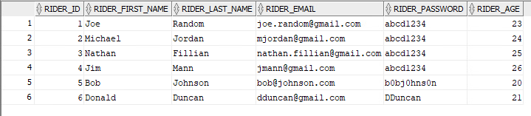

--Test 1 Create a new account

Set serveroutput on;

Exec createrideraccount('James', 'Shaw', 'jshaw@gmail.com', 'JShaw', 23);

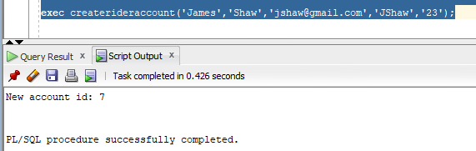

--Show updated table

Select * from rider;

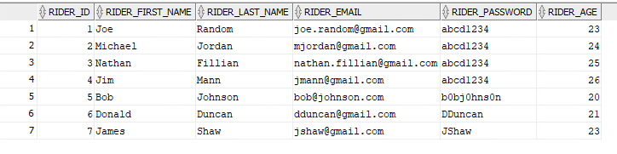

-- Test 2 Account already exists

Set serveroutput on;

Exec createrideraccount('James', 'Shaw', 'jshaw@gmail.com', 'JShaw', 23);

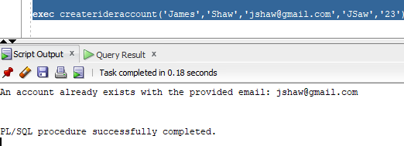

**Task 2:**

--Test 1 Successful login

Set serveroutput on;

Exec loginrider(‘jshaw@gmail.com’,’JShaw’);

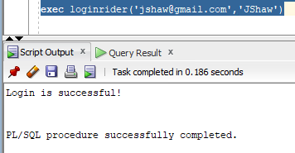

--Test 2 Invalid email

Set serveroutput on;

Exec loginrider(‘billy@gmail.com’,JShaw’);

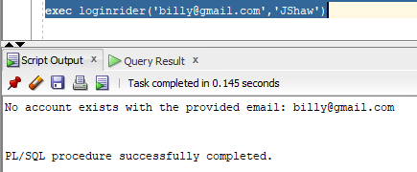

--Test 3 Wrong password

Set serveroutput on;

Exec loginrider(‘jshaw@gmail.com’, ‘Saw’);

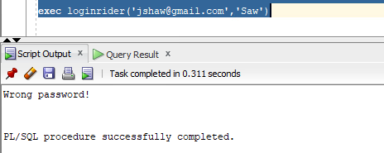

**Task 3:**

Select * From Metro card

---- card id for each account id starting with 1

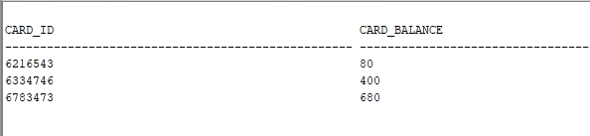

---- Create new Metro Card with valid account id

Valid Input

Set serveroutput on;

Exec buynewcard(1,200);

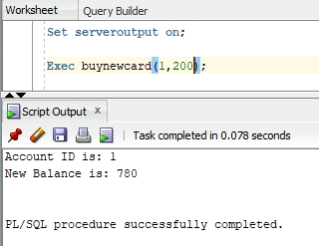

---- Metro card balance increased for account ID 1, tried multiple times thats why the new balance shown does not add up

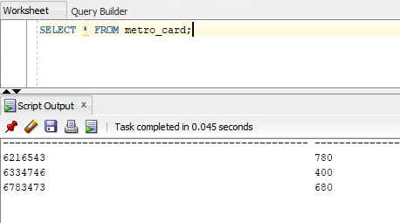

Invalid Input

Set serveroutput on;

Exec buynewcard(345,200)

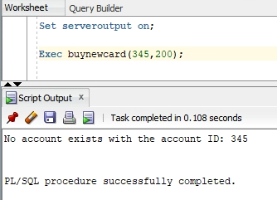

**----- All riders ages**

**Select * from riders**



**----- Look up discount ID for account 1**

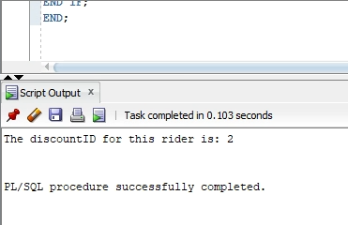

**----look up for discount ID for account 2**

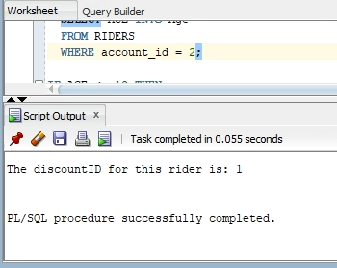

**----look up for discount id for account 3**

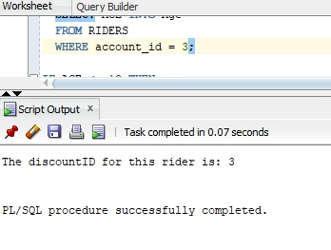

**Task 4:**

Set serveroutput on;

declare

newBalance number;

begin

Addmoney(6783473,50,newBalance);

dbms_output.put_line(' The new balance is: '|| newBalance);

end;

Valid input

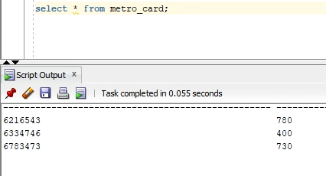

Invalid Input

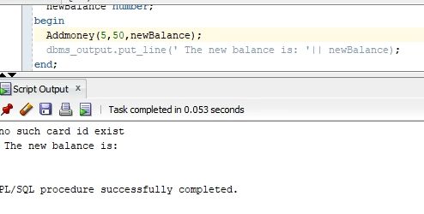

**Task 5:**

*SELECT * FROM rider;*

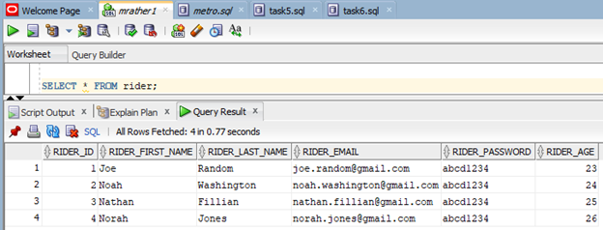

*SELECT * FROM metro_card;*

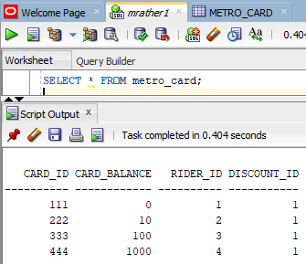

***RIDER 2: Valid Test Scenario***

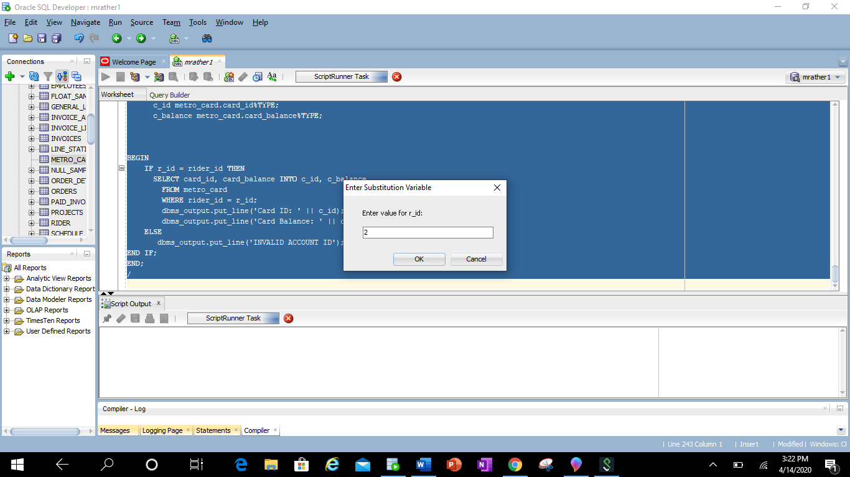

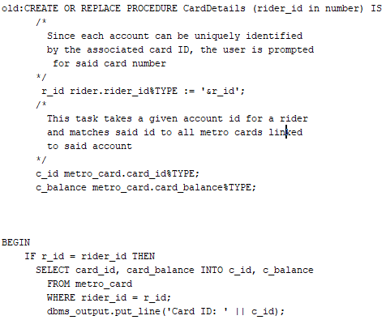

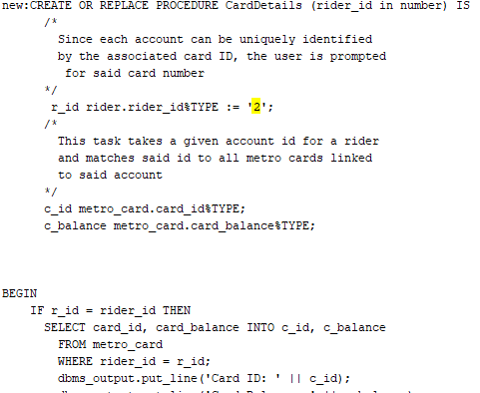

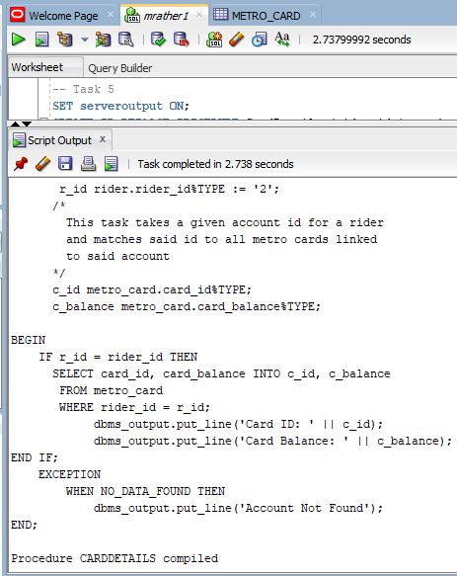

**Display of Procedure**

SET serveroutput ON;

execute CardDetails(2);

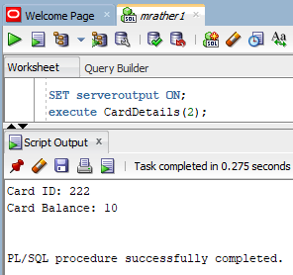

***RIDER 5: Invalid Test Scenario***

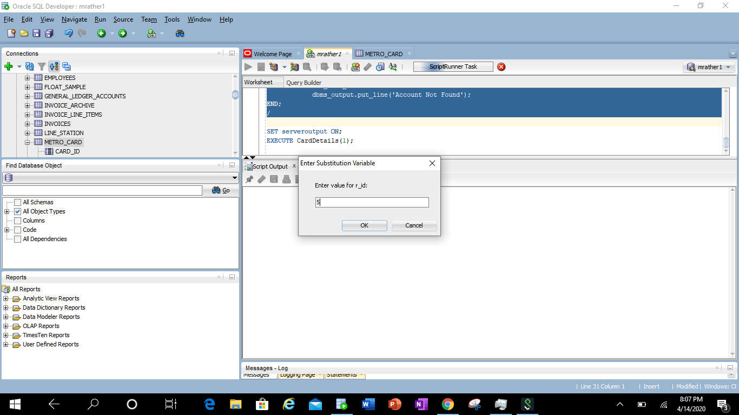



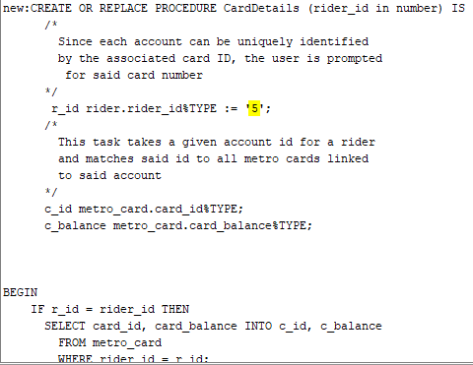

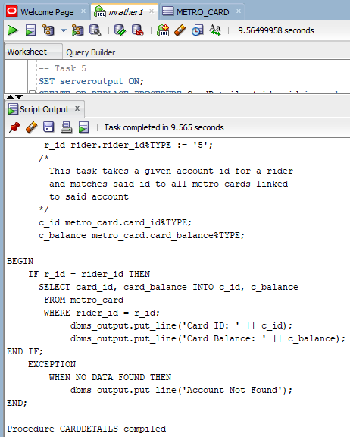

**Display of Procedure**

SET serveroutput ON;

execute CardDetails(5);

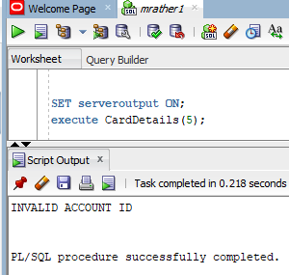

**Task 6:**

*SELECT * FROM transactions;*

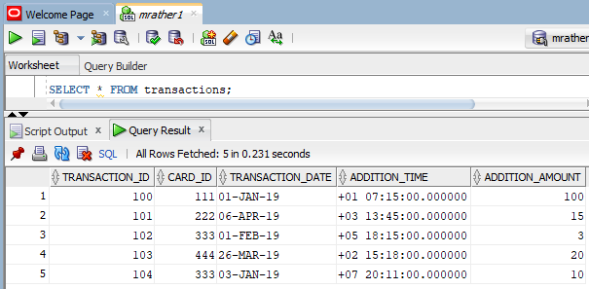

***CARD 1: Valid Test Scenario***

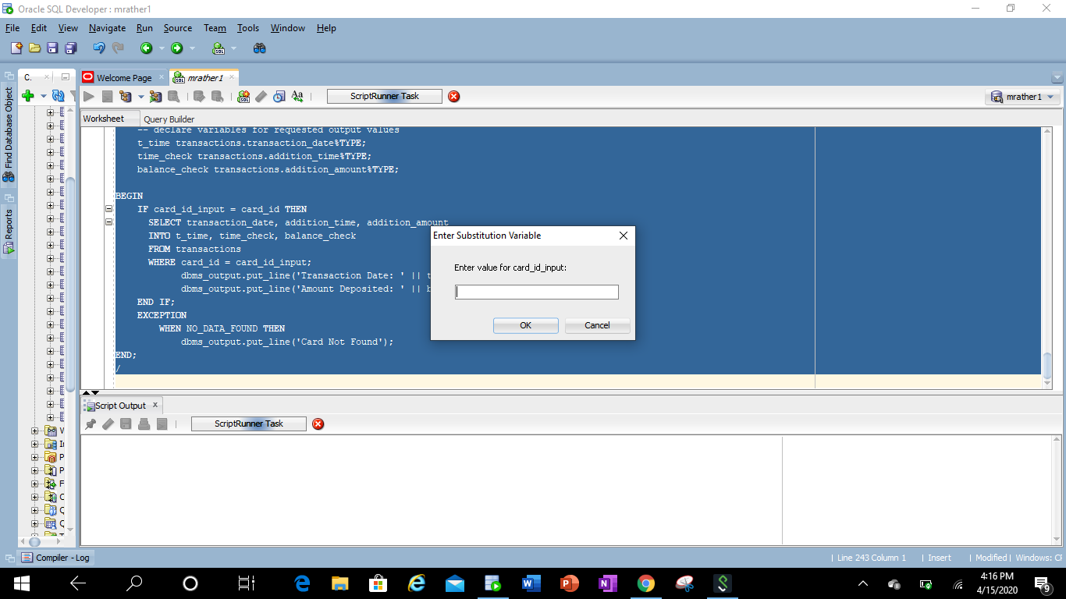

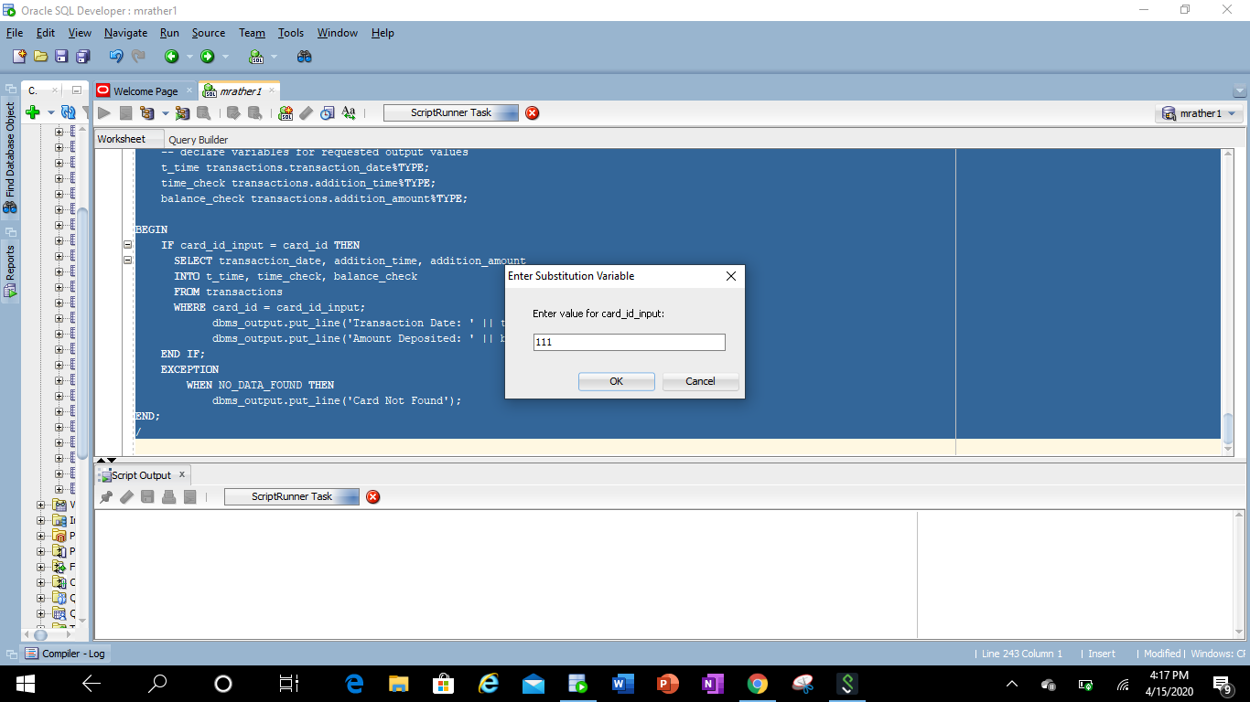

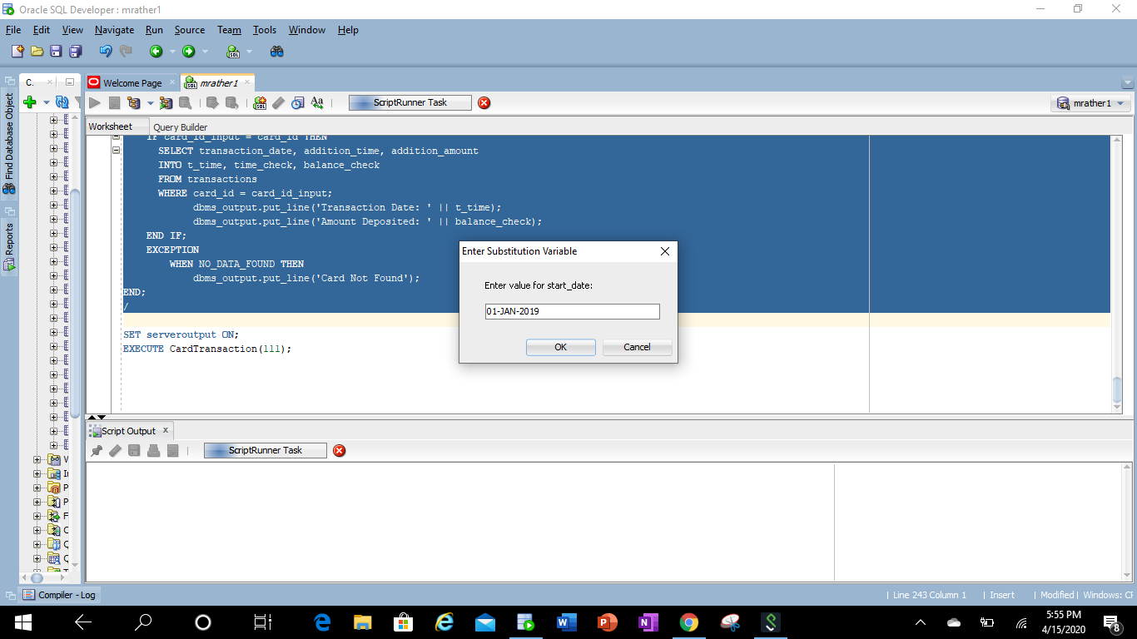

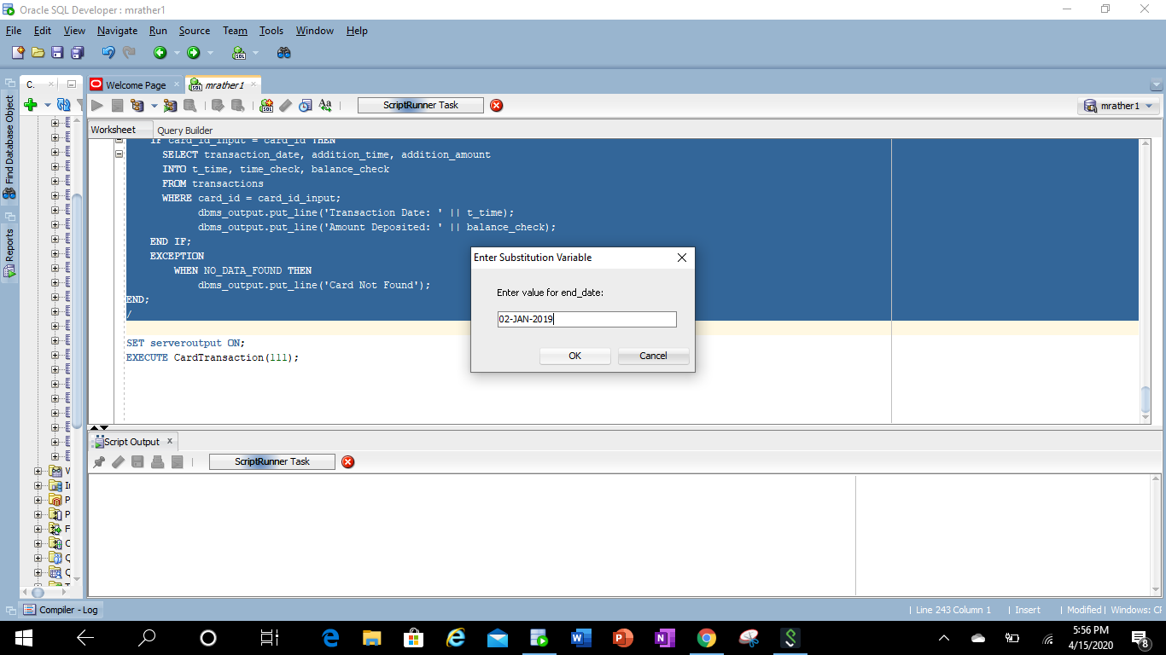

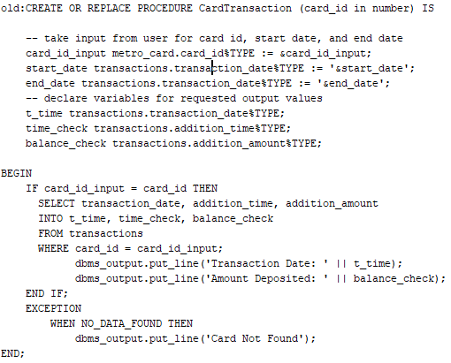

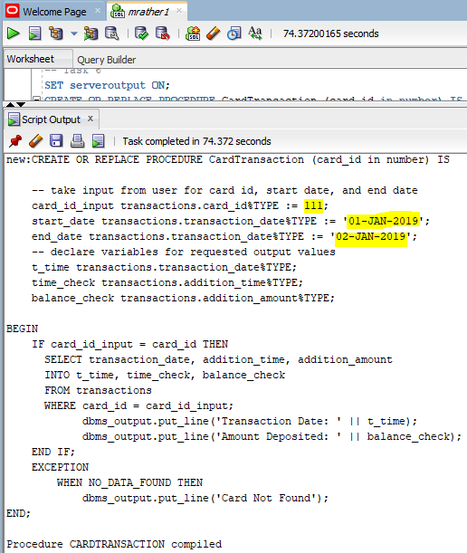

**Display of Procedure**

SET serveroutput ON;

EXECUTE CardTransaction(111);

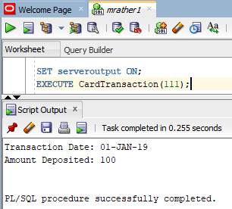

***CARD 2: Invalid Test Scenario***

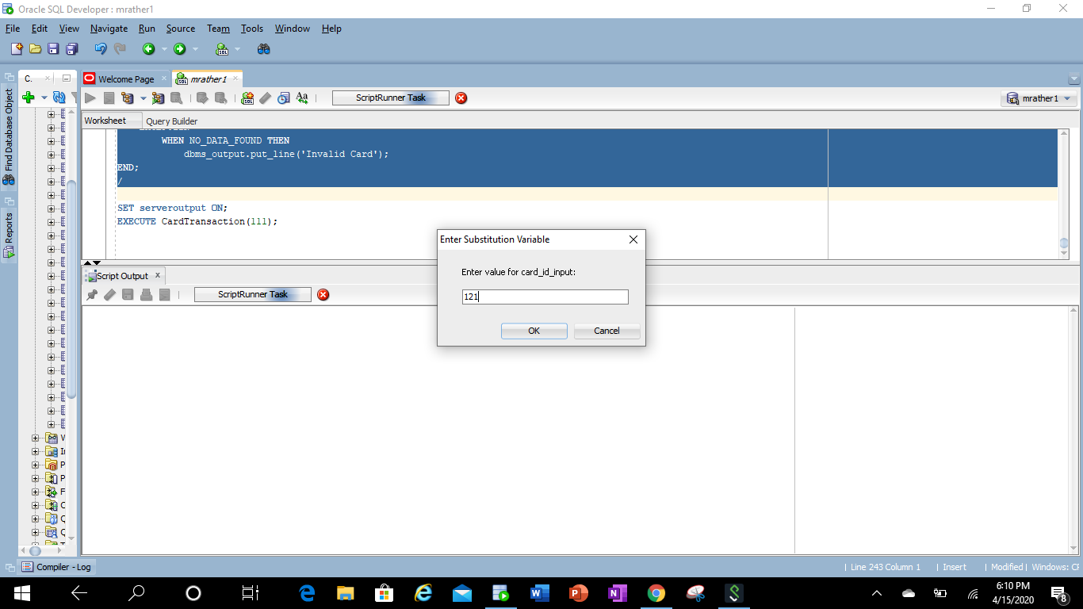

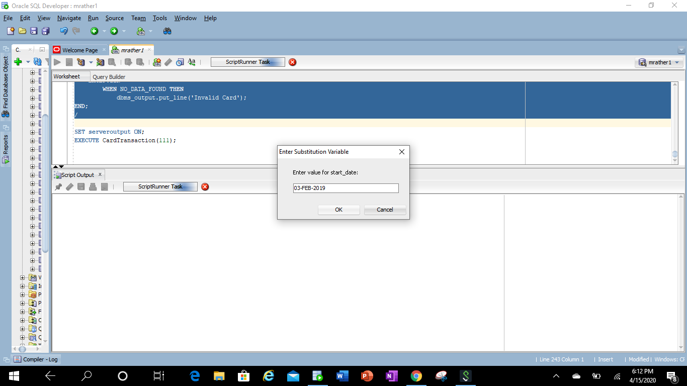

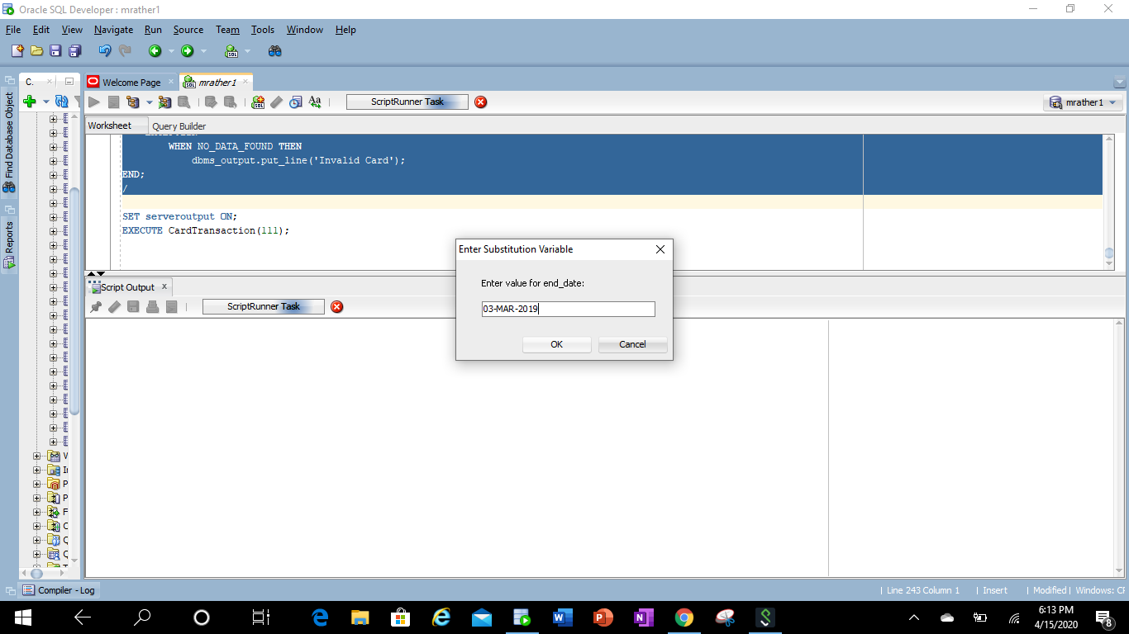

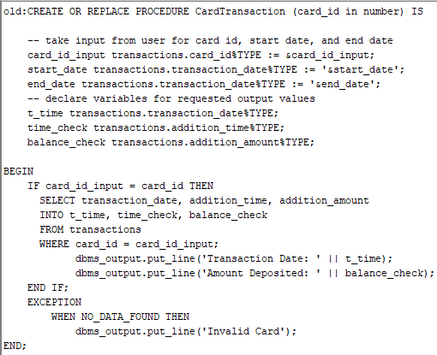

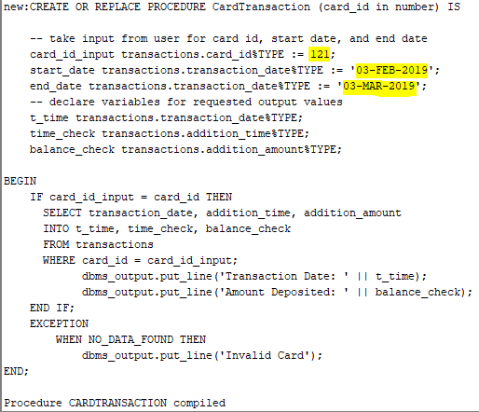

**Display of Procedure**

SET serveroutput ON;

EXECUTE CardTransaction(121);

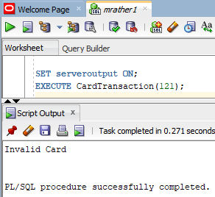

**Task 7:**

Set serveroutput on;

Exec

**Task 8:**

Set serveroutput on;

Exec checkdeparture(greenbelt, 1500)

SET serveroutput ON;

CREATE OR REPLACE PROCEDURE checkdeparture(station_name, arrival_time )

DECLARE

-- take input from user for time, and station name

time_input schedule_station.arrival_time%TYPE := '&time_input';

station_input station.station_name%TYPE := '&station_input';

-- declare variables for requested output values

schedule_id_output schedule.schedule_id%TYPE;

line_name_output train_line.line_name%TYPE;

direction_output schedule.direction%TYPE;

station_name_check station.station_name%TYPE;

BEGIN

SELECT station.station_name

INTO station_name_check

FROM station

WHERE station_name = station_input;

FOR result_info IN (

SELECT schedule_id, direction

INTO line_name_output, direction_output

FROM schedule, train_line

WHERE schedule.line_id = train_line.line_id

)

LOOP

dbms_output.put_line('Line: ' || line_name_output ||

' Direction: ' || direction_output);

END LOOP;

EXCEPTION

WHEN NO_DATA_FOUND THEN

dbms_output.put_line('Station Not Found');

END;

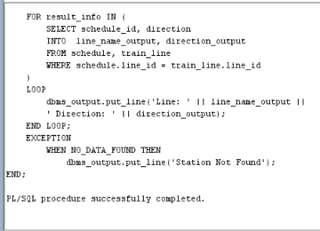

Schedule_Station table

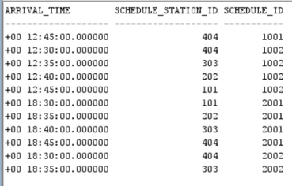

Train_line table

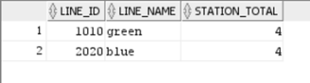

Schedule table

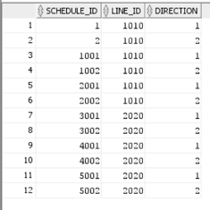

Station table

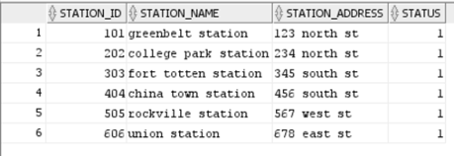

**Task 9:**

**--Test 1 increasing**

Set serveroutput on;

DECLARE

message NUMBER;

BEGIN

message := task9('greenbelt station', 'college park station', 1010);

DBMS_OUTPUT.put_line(message);

END;

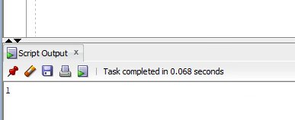

--Test 2 decreasing

Set serveroutput on;

DECLARE

message NUMBER;

BEGIN

message := task9('college park station', 'greenbelt station', 1010);

DBMS_OUTPUT.put_line(message);

END;

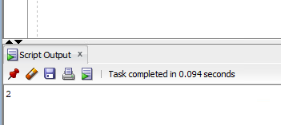

**Task 10:**

--different line test

Set serveroutput on;

Exec Task10(INTERVAL '0 7:40:00.00' DAY TO SECOND, INTERVAL '50' MINUTE, 'college park station', 'rockville station', 'green');

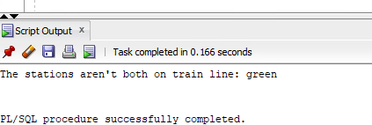

--same line test

Set serveroutput on;

Exec Task10(INTERVAL '0 7:40:00.00' DAY TO SECOND, INTERVAL '50' MINUTE,'college park station', 'greenbelt station', 'green');

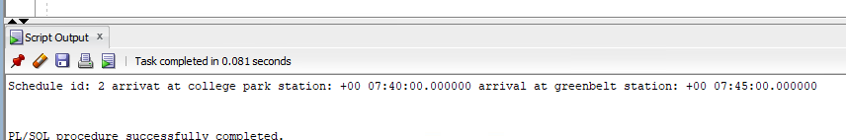

--same line test

Set serveroutput on;

Exec Task10 (INTERVAL '0 7:40:00.00' DAY TO SECOND, INTERVAL '500' MINUTE,'college park station', 'greenbelt station', 'green');

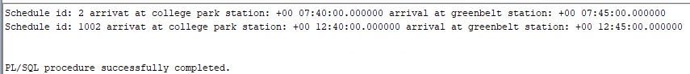

**Task 11:**

--same line test

Set serveroutput on;

Exec task11( 'college park station', 'greenbelt station');

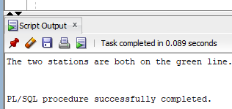

--different line test

Set serveroutput on;

Exec task11('college park station', 'rockville station');

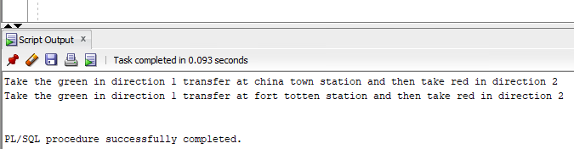

**Task 12:**

Set serveroutput on;

Exec task12;

